**Bus Ticket Booking System**

**Objectives:-**

o The main objective of the Bus Ticket Booking system is to manage the details of bus, ticket, booking, agents ,seats.  
o It manages all the information about bus ,customer ,seats.  
o The project is totally build at administrative end and thus only the administrator is  
 guaranteed the access.  
o The of the project is to build an application program to reduce the manual work for  
 managing the bus ,ticket ,customer, booking.

**Requirement Specification**

**Functional Requirements**

**• Admin Login** :

1. Add route details, bus details ,ticket fare  
2. Update bus ,route details  
3. Delete route, bus details  
4.Veiw passenger details  
5. Logout

**• User Login :**

1. Book bus ticket  
2. Cancelation of Booking  
3. Veiw bus details  
4. Logout

**Non Functional Requirements:-**

Sl.No Hardware/Equipment Specification

1 Processor Intel Processor  
2 Clock speed 2.60GHz 2.61 GHz  
3 Screen Resolution 1024*786 Pixel  
4 Keyboard QWERTY  
5 RAM 8 GB

**Software Requirements:-**

|  |  |  |
| --- | --- | --- |
| **Sl.No** | **Software** | **Specification** |
| 1 | Web Browser | Google chrome |
| 2 | Operating System | Windows 10 |
| 3 | Scripting Languages | HTML, CSS, JavaScript, JSP,JDBC,Servlet |
| 4 | Database | MySQL 8.0.12 |
| 5 | Server used | Apache Tomcat server v10.0 |
| 6 | Workbench used | Eclipse IDE for Enterprise Java and Web Developers - 2022-12 |

**IMPLEMENTATION**

The project is implemented using MySQL database along with JSP,servlet and HTML. In this project, we use the below mentioned concepts for implementing different type of effects like HTML pages to demonstrate on a web page as a stand-alone or web based application. It is a three tier architecture project.

A three-tier architecture is a client-server architecture in which the functional process logic, data access, computer data storage and user interface are developed and maintained as independent modules on separate platforms. Three-tier architecture is a software design pattern and a well-established software architecture.

**Bus Ticket Booking System**

**Welcome Page**

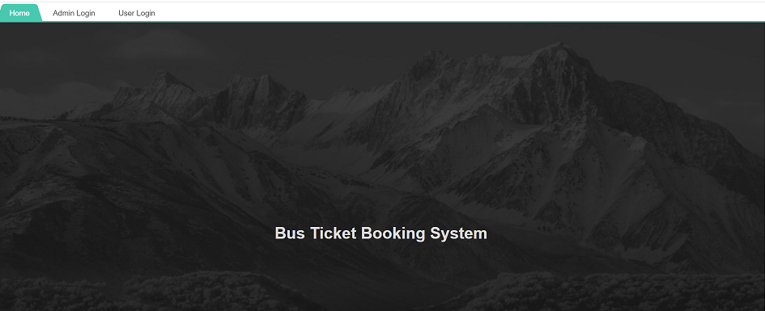

Figure no 1:-welcome page

The above Image is the beginning of bus booking system it contains the admin and the user login.

**Admin login**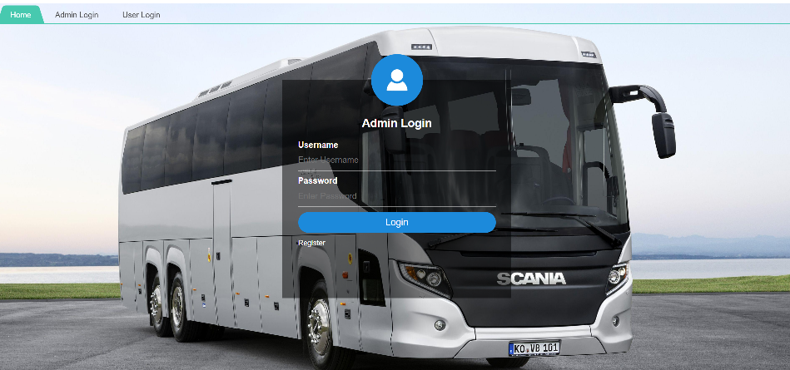

Figure no 2:- Admin login

**Admin Register Form** 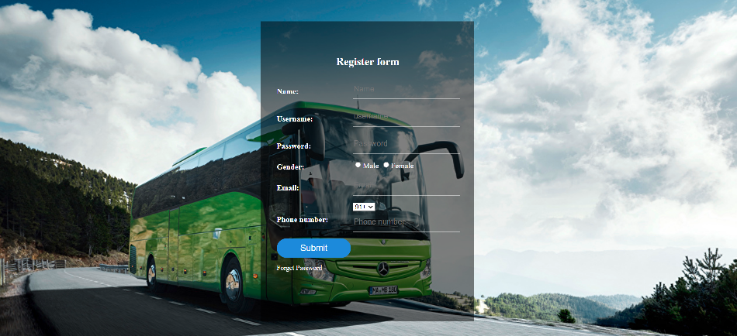

Figure no 3:- Admin Register From

This is the Registration page for both Admin and User.

**Admin menu**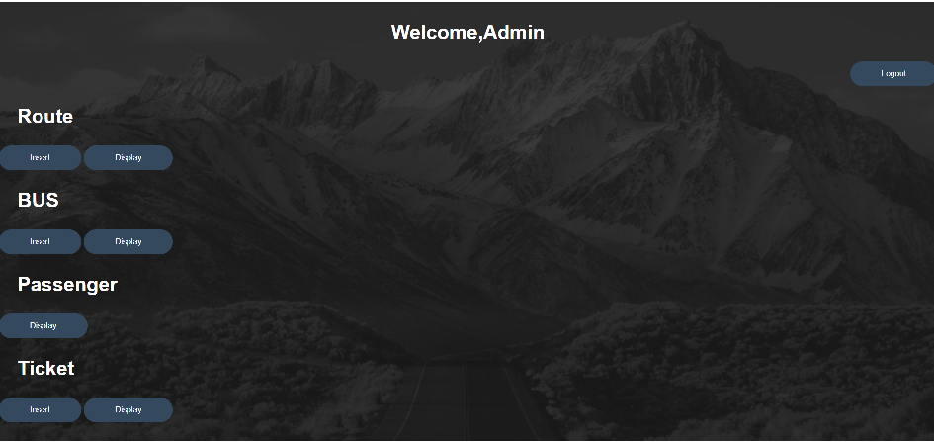

Figure no 4:- Admin menu

The above Image is the display of admin menu ,the menu contains Route, Bus ,Passenger, Ticket.

**Route details page**

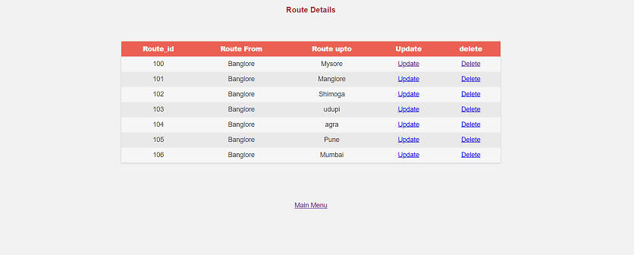

Figure no 5:- Route details page

**Bus details page**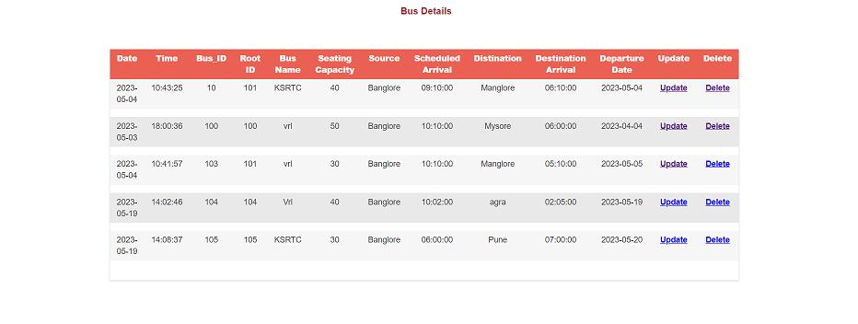

Figure no 6:- Bus details page

**User login page**

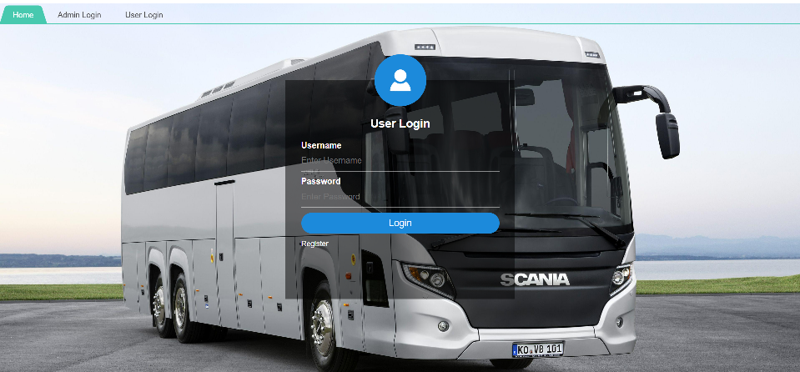

Figure no 7 :- User login page.

**User menu page**

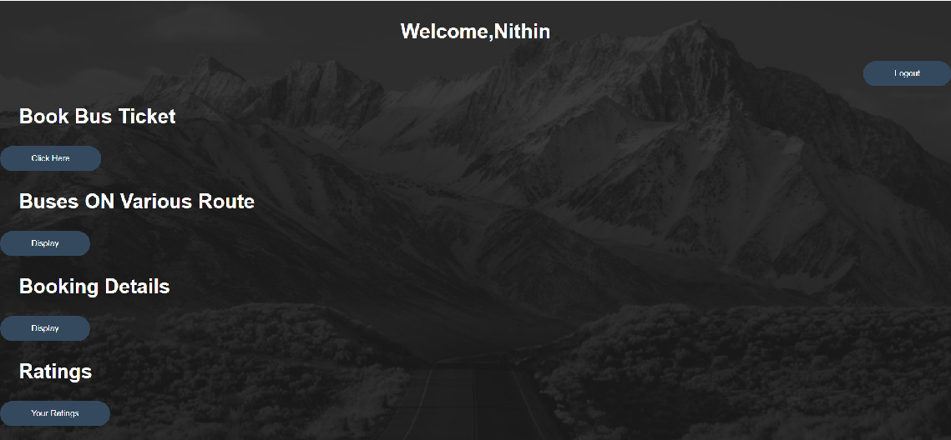

Figure no 8 :- User menu page

**Journey details page**

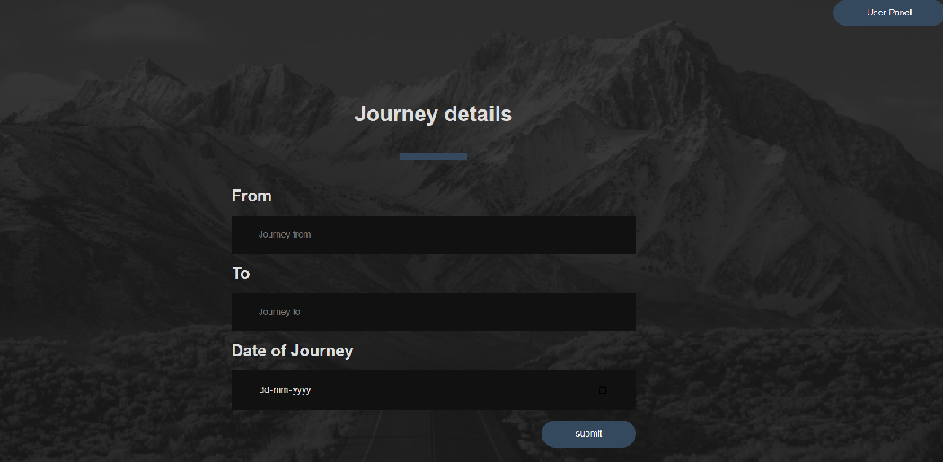

Figure no 9 :- Journey details page.

**ON route bus details**

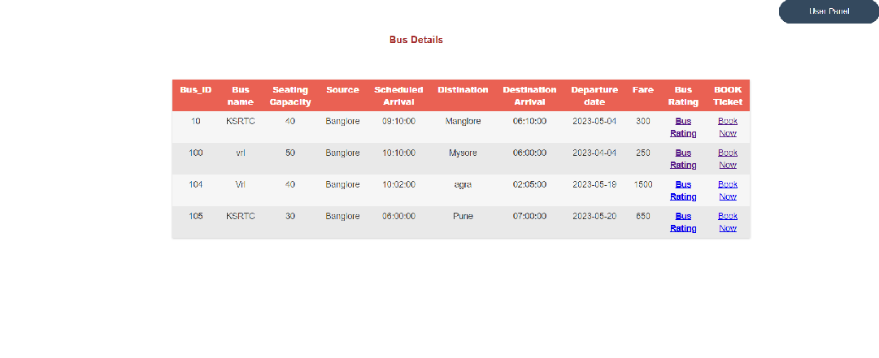

Figure no 10 :- on route bus details

The above Image contains the bus details,on which user want’s to trave

**Passenger details Page**

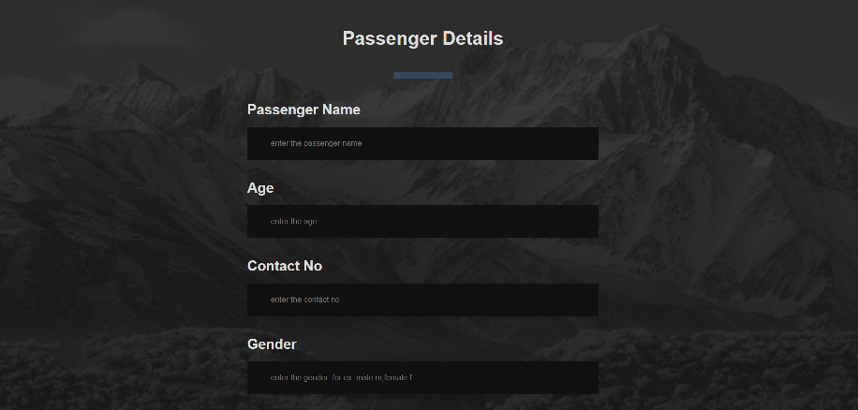

Figure no 11 :- Passenger details Page

The above Image is used to insert the passenger details

**CONCLUSION**

The system is completely menu driven and extremely user friendly since it is developed in an efficient front end tool . Appropriate error messages are also provided too guide the user in a proper and user friendly manner.

The software “Bus Ticket Booking System” has been developed in windows 2010 environment using HTML/CSS as front end and JSP as back end. Time consumptions reduced to a great extent and user as less complexity in handling it database.  
Searching and retrieving of bus records will be easier since there would be a search module that will filter all bus records.